WEBD6211 — PART 1
PROJECT PROPOSAL 1 — ETHEYS FASHION FEASTER
Target Organisation: Small Business / Retail Store
Student Name: Ethel Muofhe
Student Number: [ST10317760]
Group: [01]
Academic Year: 2026
Academic website project — fictional organisation scenario

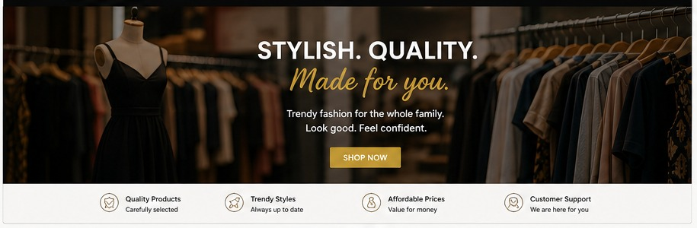
Figure 1: Concept visual for the proposed organisation. Images are documented in the image-source log.

Table of Contents
1. 1. Organisation Overview
2. 2. Website Goals and Objectives
3. 3. Current Website Analysis
4. 4. Proposed Website Features and Functionality
5. 5. Design and User Experience
6. 6. Technical Requirements
7. 7. Timeline and Milestones
8. 8. Budget
9. 9. References
Lecturer Approval

1. Organisation Overview
Etheys Fashion Feaster is a fictional small fashion retailer based in Limpopo, South Africa. The business offers affordable fashion for women, men and children. The website will give the business an online presence where customers can learn about the organisation, browse product categories and make enquiries. It demonstrates how web technology can improve visibility and customer communication.

Mission and Vision
- Mission: To provide trendy, good-quality and affordable fashion that inspires confidence.
- Vision: To become a trusted fashion destination known for style, quality and customer service.
- Target audience: Local families, young adults and customers looking for stylish, affordable clothing.

2. Website Goals and Objectives
- Create a professional online presence for Etheys Fashion Feaster.
- Showcase women’s, men’s and children’s product categories.
- Generate customer enquiries through a clear enquiry form.
- Make business information, locations and contact channels easy to find.
- Provide an accessible, responsive and easy-to-navigate user experience.
- KPIs: page visits, completed enquiries, successful navigation, mobile usability and zero broken internal links.

3. Current Website Analysis
The organisation is fictional and therefore does not have an existing website in this academic scenario. The main opportunity is to establish a clear online identity from the beginning. The proposed website addresses common small-business needs by placing the most important information—products, organisation details, enquiry options and contact information—within a small number of clearly labelled pages.

4. Proposed Website Features and Functionality
- Home page with hero image, introduction and calls to action.
- About page containing history, mission, vision and values.
- Products page with women’s, men’s and children’s collections.
- Enquiry page with client-side validation for product and general enquiries.
- Contact page with two proposed Limpopo locations and a map/location area.
- Consistent navigation, footer links, semantic HTML and responsive layout.

5. Design and User Experience
The design will use a modern fashion aesthetic with a black, gold, white and light-grey palette. Poppins will be used for headings and Arial/Helvetica for body text to create a clear hierarchy. The layout uses strong imagery, product cards, whitespace and prominent call-to-action buttons. Navigation remains consistent across all pages. Accessibility considerations include semantic elements, meaningful image alternative text, form labels, keyboard-friendly controls and responsive layouts. Low-fidelity wireframes and the sitemap are included in the repository.

6. Technical Requirements
The website will be developed using HTML5, CSS3 and JavaScript in Visual Studio Code. Git and GitHub will be used for version control. The final production site could use a .co.za domain and standard shared hosting; GitHub Pages may be used for an academic prototype. The site will be tested in current desktop and mobile browsers.

7. Timeline and Milestones
- Week 1: research, target organisation selection and two proposals.
- Week 2: lecturer approval, content research, sitemap and low-fidelity wireframes.
- Week 2–3: HTML structure, CSS styling and responsive layout.
- Week 3: JavaScript enquiry validation and navigation testing.
- Week 4: cross-browser/mobile testing, README, GitHub commits and final submission.

8. Budget
- Planning and UI/UX: R800
- Website development: R1,800
- Domain registration: R250
- Hosting: R600
- Content/testing: R250
- Maintenance allowance: R100
- Estimated project total: R3,800

9. References
- MDN Web Docs. HTML, CSS and JavaScript documentation. https://developer.mozilla.org/
- GitHub Docs. GitHub repository and version-control documentation. https://docs.github.com/
- Google Fonts. Poppins typeface. https://fonts.google.com/
- OpenStreetMap. Map data used only as a proposed location reference where applicable. https://www.openstreetmap.org/

Lecturer Approval
Approved / Not Approved (circle one): ______________________________
Lecturer comments: ______________________________________________________________
Lecturer name/signature: ______________________________ Date: _______________

